**Virginia ranks 6th in active federal human trafficking cases**

New report shows statistics on number of federal human trafficking cases

WASHINGTON D.C. – Nearly two thousand cases of human trafficking saw a courtroom in the United States last year. Virginia is one of the most aggressive states when it comes to prosecuting this offense according to a new report by the Human Trafficking Institute.

The report is the first of its kind and the first snapshot given of the number of federal human trafficking cases across the country and the commonwealth over the past decade.

The new report shows which states are most actively combating human trafficking crimes and [how the commonwealth measures up.](https://www.traffickingmatters.com/wp-content/uploads/2018/09/Virginia-State-Report-WEB.pdf)

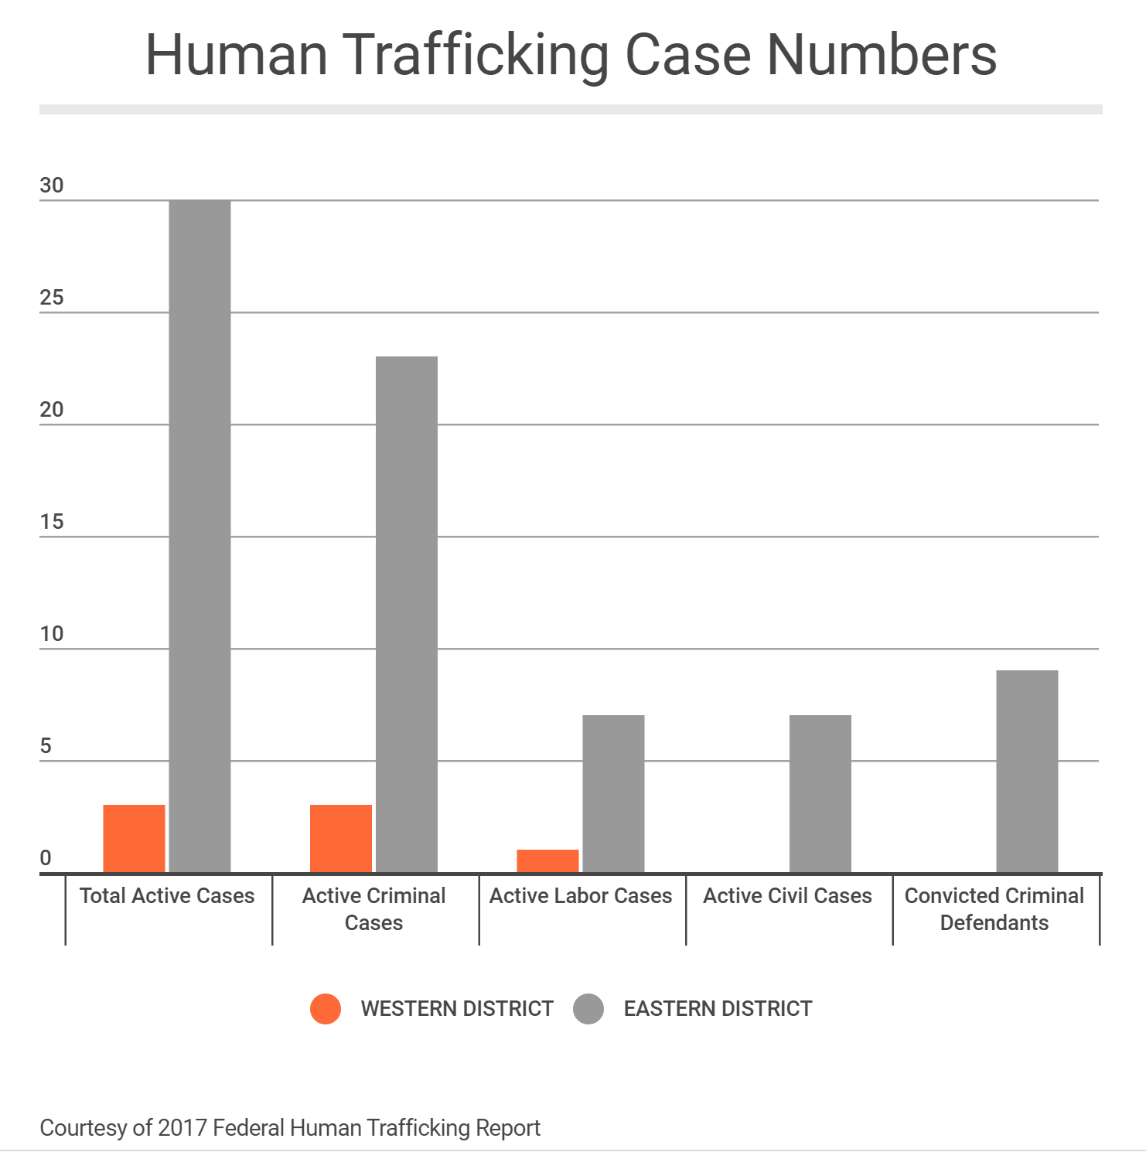

The report provides an account of all the criminal and civil human trafficking cases handled by federal courts during 2017.

A team of 12 attorneys and 8 law school students reviewed every human trafficking case in the federal court system in 2017.

In addition, court documents, press releases, and news sources were used to gather a comprehensive set of data to include type of trafficking case, business model, age of the victim, and district where the case took place, among others.

Out of all states and U.S. territories, Virginia ranks 6th for the most human trafficking cases on federal court dockets.

Kyleigh Feehs, Associate Legal Counsel for the Human Trafficking Institute composed the report. She said the team hopes the data can be used to help policy makers across the country.

"What we are realizing is that traffickers are currently acting with impunity and there is a need for accountability in this space,” Feehs said. “As part of that process we wanted to publish this report to look at what are we doing here within the United States to increase those efforts to hold those traffickers accountable.”

In 2017, there were 783 active criminal and civil human trafficking cases involving 1,930 defendants working their way through the federal court system in the United States.

According to the report, 88.8% of active human trafficking cases were criminal matters and 11.2% were civil suits.

In 2017 there were 33 active human trafficking cases in Virginia.

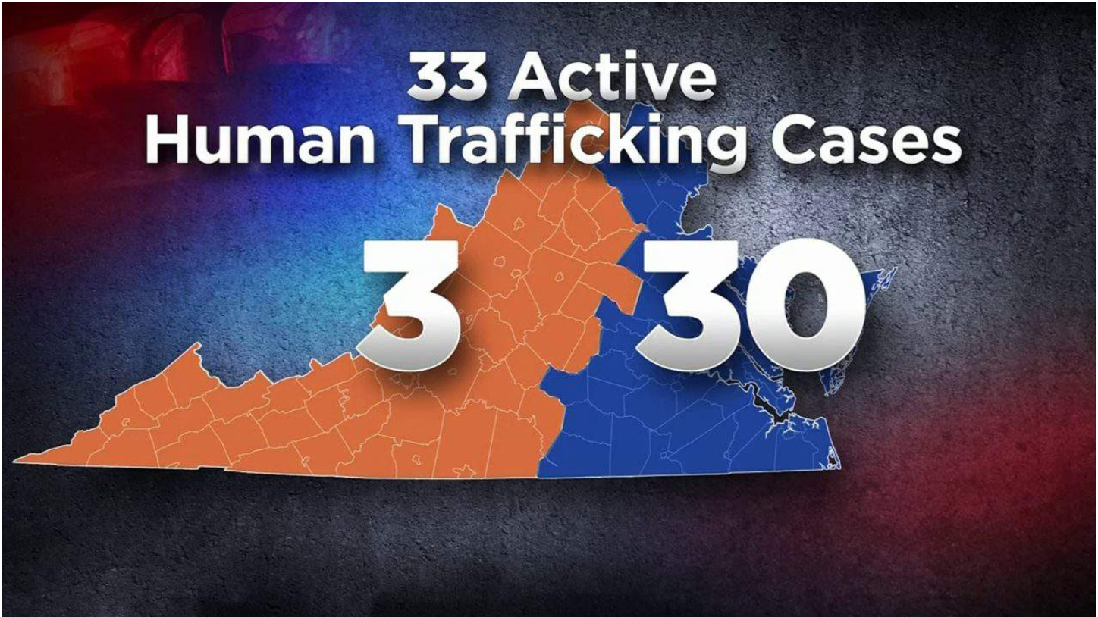

Three of those cases were in the Western district, while the remaining 30 were in the eastern district. Feehs said the report doesn't reflect the prevalence of the crime, but instead how aggressively law enforcement is pursing the perpetrators. She said due to the population makeup of the eastern district, it is no surprise that more cases were prosecuted there.

Virginia's 33 active human trafficking cases in 2017 generated 401 federal charges involving 74 defendants.

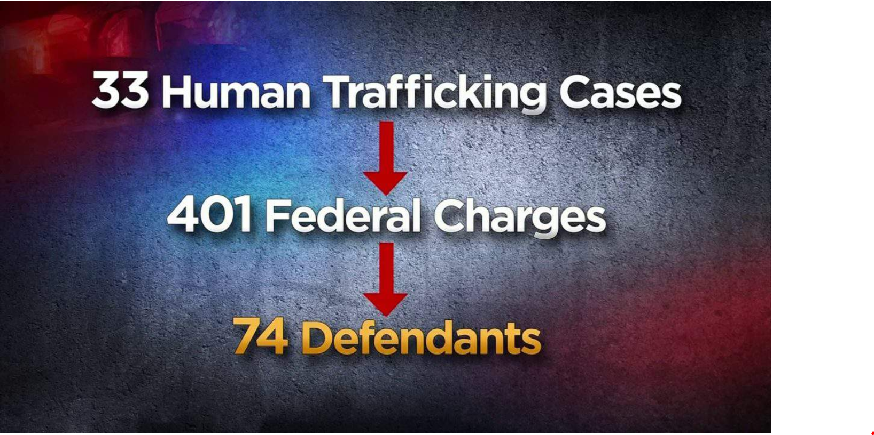

Of those 33 cases, 75 percent involved sex trafficking and the remaining 25 percent of cases involved labor trafficking.

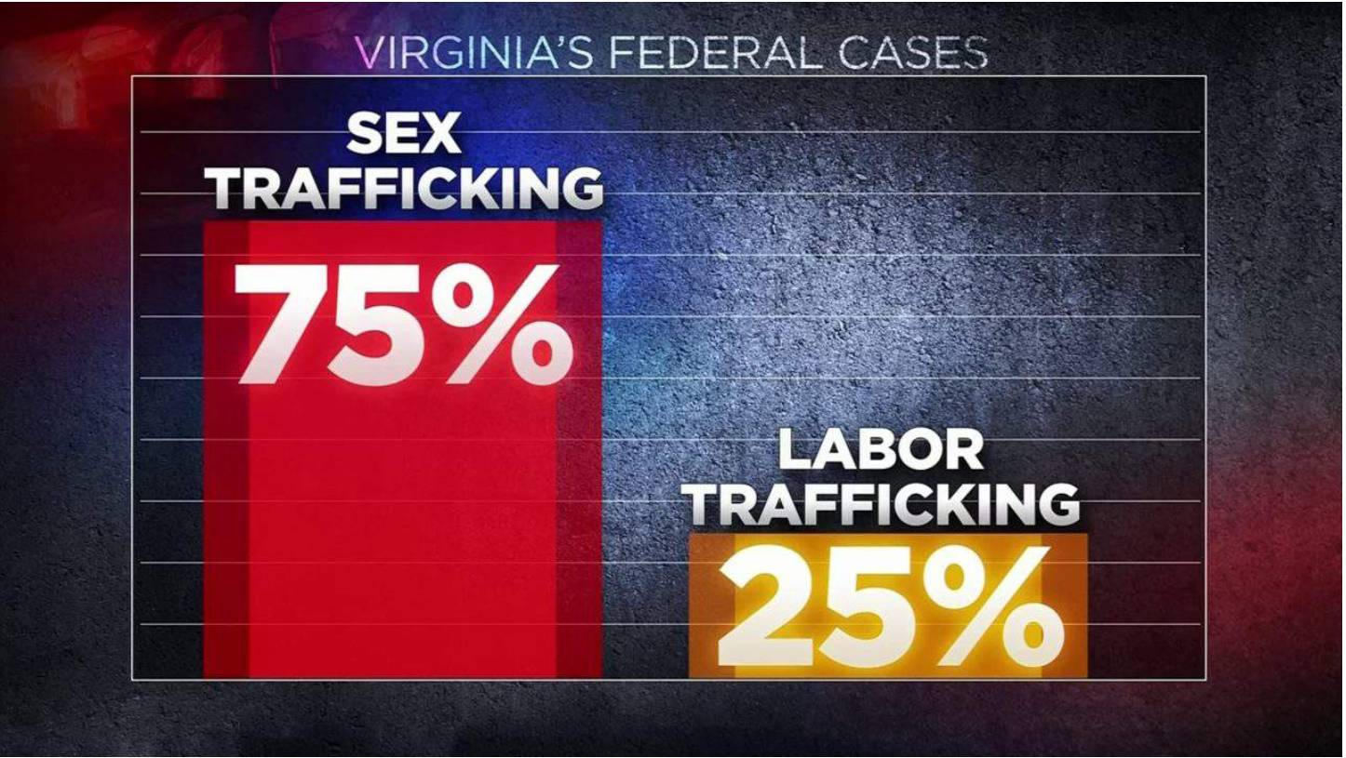

“We really want these numbers to fuel conversation of what we can do to increase the amount of time that the defendant is ordered to pay restitution to his or her victim,” Feehs said.

Two defendants were ordered to pay restitution in Virginia in 2017, ranking the state 9th of 55 (tied with 4 other U.S. states and territories).

*Copyright 2018 by WSLS 10 - All rights reserved.*